Project Timeline

Week Ending 3/29
- Plant model
- MPC working
Output: Plots of quadcopter trajectories through space with quantification of controller objectives

Week 4/5
- Add delay
- Add wind
- Add mismatch
- Add constraints
- Run experiments
- First draft of adaptive discretization / mitigation
Output: Plots of trajectories impacted by whatever complications we choose. For instance, a plot of before & after trajectories in the presence of a wind disturbance.

Week 4/12
- Compare results
- Make presentation
Output: Presentation with problem statement, implementation, and simulation results

Final 10 Days
- Write paper
- Clean figures
- Edit
Output: Finished paper.

Problem Title

Abstract
Quadcopters and other small drones continue to grow in use and in societal importance. Their uses vary widely, from product and warhead delivery, to safety inspections and recreational entertainment, but all have a need to accurately control the vehicle towards some objective. Model Predictive Control (MPC) presents as a promising candidate for achieving robust and efficient control because of its ability to balance processing power and adapt to changing conditions. This work explores MPC’s ability to accomplish a goal representative of many of today’s use cases - the need to traverse between two points within some time constraint in an uncertain environment with an imperfect model of the vehicle’s performance. Further, it investigates the feasibility of an adaptive time step and prediction horizon as a means of increasing the robustness of the controller against such complications. As the model’s assumptions become less reflective of the system reality, the controller attempts to improve the quality of its linearization by reducing the model time step and adjusting its prediction horizon within a computational budget. This study investigates how MPC discretization and horizon design choices influence robustness to model mismatch and disturbances in constrained trajectory problems, and whether adaptive discretization strategies improve feasibility robustness under a fixed computational budget.

Introduction

Problem Definition
In December 2013, Jeff Bezos introduced a revolutionary idea at the time - that Amazon could use drones to deliver items 5 pounds or less within 10 miles and in 30 minutes or less. While that goal is still unmet, major firms like Alphabet, Walmart, and UPS, are pursuing similar capabilities and drones utility continues to expand in global health with medicine and vaccine delivery presently in Africa and organ transplant delivery being explored within the US. Furthermore, the ongoing conflicts in Ukraine and Iran demonstrate the utility, effectiveness, and economics of drone payload delivery in global warfare, for better or worse. As these incentives continue to expand in importance and prevalence, the need for robust drone control to accurately enable targeted delivery to remote or specific areas under uncertainty will increase.
Robust drone control occurs in dynamic environments, which have unpredictable disturbances and which utilize imperfect vehicle models. Model Predictive Control (MPC) is a good candidate for drone control automation because of its ability to handle constraints and a wide range of objectives under uncertainty. However, MPC performance depends heavily on the characteristics of its discretization and time horizon, in relation to its environment and mission objectives. These choices are limited by computational resources and knowledge of the mission specifics.
Objectives and Scope
The technical objective is to investigate the control and behavior of a quadcopter operating under a set of structured complications that have the potential to introduce realistic failure modes and to explore how adaptively tuning MPC hyperparameters can serve to mitigate or delay them. The complications selected for study include:
- Unobservable disturbance, modeled as a vertical wind profile with turbulence and gusts,
- Model mismatch between controller prediction dynamics and true vehicle performance
- State and input constraints, including obstacle avoidance and time-of-arrival requirements
Each of these elements introduces a distinct mechanism by which feasibility or performance degradation may occur. The work explores how these failure modes manifest within a model predictive control (MPC) framework and to evaluate mitigation strategies that preserve feasibility and performance.
Experiment Design
A reduced-order quadcopter model is formulated and embedded within a Model Predictive Control (MPC) framework for estimating the evolution of the vehicle state over discretized time. This model represents the dynamics used internally by the controller for prediction and optimization.
A Model Predictive Controller is then established with a baseline set of hyperparameters, including discrete time step, prediction horizon duration, and number of horizon steps. These baseline settings serve as a reference configuration against which alternative controller configurations will be compared.
A computational budget is defined to represent the practical limitations of edge computing on modern laptop-class processors. Controller configurations must operate within this computational budget, introducing a realistic tradeoff between prediction fidelity and computational tractability.
A higher-fidelity system model is selected to simulate the true evolution of the vehicle state over time. This model is used as the plant in simulation and may differ from the controller’s internal model in order to introduce controlled model mismatch.
To represent environmental disturbances, a wind model is incorporated. The Von Karman turbulence model is selected because it produces a realistic disturbance environment including both stochastic turbulence and structured gust behavior. This disturbance is treated as unmeasured by the controller and therefore acts as a source of prediction error.
An initial set of design factors is selected for study. These factors represent both controller design choices and environmental/model uncertainty parameters. The primary factors considered include:
- Discrete timestep
- Prediction horizon duration
- Number of horizon steps
- Constraint tightness
- Amount of model mismatch
- Wind intensity / turbulence parameters
- Adaptive vs. fixed discretization
A set of constraints is defined that is intentionally challenging but achievable, including actuator limits, obstacle avoidance constraints, and a time-of-arrival constraint. These constraints are selected such that feasibility may be threatened under disturbance or model mismatch, allowing the study to evaluate controller robustness.
An initial baseline set of tests is performed to establish nominal system behavior under near-ideal conditions, where wind disturbance and model mismatch are minimized. Baseline performance is used as a reference for assessing performance degradation or improvement when complications are introduced.
A Latin Hypercube experimental framework is then used to explore the effect of the selected design factors across the design space. For each experiment run, several outcome metrics are recorded to evaluate controller performance and robustness. These metrics include:
- Feasibility rate
- Number or magnitude of constraint violations
- Time-of-arrival error
- Control effort
- Computation time per control update
- Slack variable usage
- Feasibility loss detection or warning time
These metrics allow comparison of controller configurations in terms of performance, robustness, and computational efficiency, enabling identification of controller design choices that improve robustness to disturbance and model mismatch within a fixed computational budget.

Modelling
A quadcopter is characterized by a rigid body with four electric motors symmetrically distributed around a central body containing the system electronics. The studied model is representative of XXXX model.
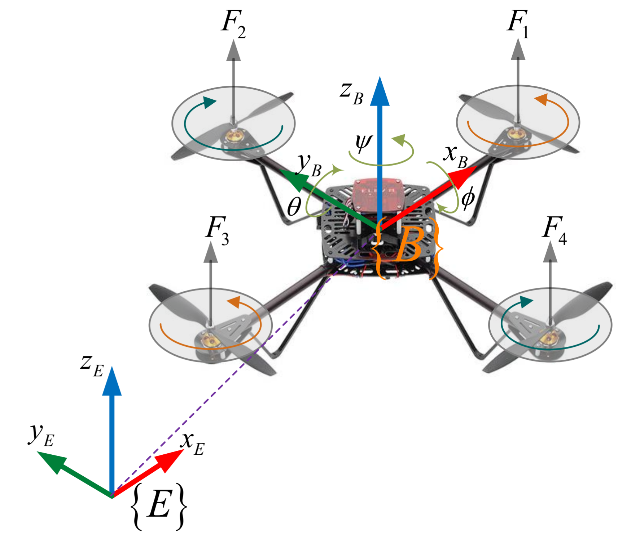
Simulation write-up. What’d we model and why?

MPC Formulation
The behavior of a quadcopter can be approximated by a linear system of continuous time equations of motion, written in the form:
$\dot{x}(t)=A*x\left(t\right)+B*u\left(t\right)+w_{c}\left(t\right)$
Where $w_{c}(t)$ represents the external disturbance of wind.
At each control update, the MPC solves a finite-horizon optimal control problem over a prediction horizon $ΔT_{H}$, discretized into $N$ steps:
$ΔT_{k}=\frac{ΔT_{H}}{N}$
This results in the discrete-time prediction model:
$x_{k+1}=A_{d}x_{k}+B_{d}u_{k}+w_{d,k}$

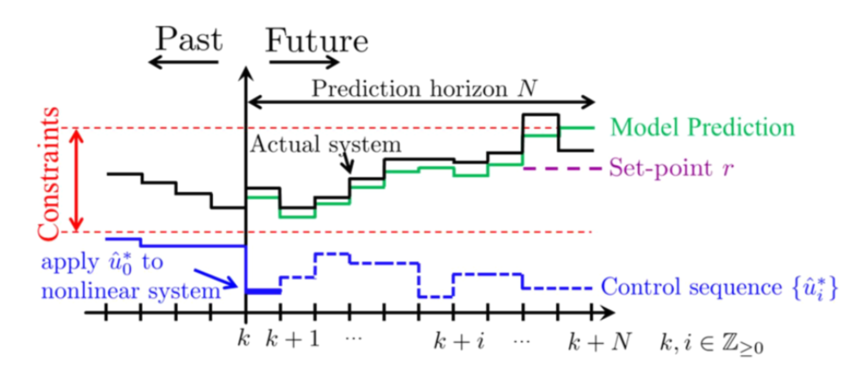

Unobservable Disturbance – Wind Profile
The system will be operating in an environment with an unmeasured disturbance, of the form of a vertical wind profile, $w_{c}\left(t\right)$, which directly affects both the vertical and longitudinal acceleration. The unobservable nature of this complication introduces a prediction error that accumulates over the controller’s horizon, potentially leading to mismatch between the predicted and actual state that may lead to constraint violations.
Model Mismatch
All models of vehicle performance are inherently imperfect, so a mismatch is introduced between the controller’s internal model and the true vehicle dynamics. This mismatch directly impacts the accuracy of the controller predictions and can lead to constraint infeasibility.
Constraints
The system is subject to several constraints on the states and inputs, including:
- Input constraints reflecting realistic limits on actuator capabilities,
- Obstacle avoidance constraint, imposed as a restriction on the vertical state component:
$h(d_{h,CNST})≤h_{CNST}$
which represents traversal beneath a bridge-like obstacle at some downstream along-path distance.
- Time-of-arrival constraint at some downstream along-path distance:
$x(t_{d_{X,CNST}})≥d_{X,CNST}$

Constraints will be accounted for using an interior-point (IP) penalty method, which enforces feasibility with an implicit safety margin.
Adaptation
The system is modeled with a linear approximation of a non-linear system of equations, which may be inappropriate when more dynamic control is required to achieve the desired behavior. To address the team will explore adaptive time discretization, where the controller adjusts $ΔT_{k}$dynamically within a fixed horizon $ΔT_{H}$. This enables finer resolution near critical regions (e.g., constraint boundaries) while maintaining computational tractability.

Theoretical Analysis

Simulation Results
Comment on how the controller was implemented and tuned, if appropriate
“Theoretical guarantees” around stability, controllability, and optimality. Others?
Numerical simulation results.

Conclusions

References

